Selections and Availability – 2022/23 Season
1. Teams shall be selected & finalised by the Selection Committee at practice on Thursday afternoons and announced that evening in the clubrooms.
If practice is cancelled because of inclement weather, it is the responsibility of each player to contact a Club Selector or their previous Team Captain to confirm what grade, where and what time they are playing.
2. Any player with a selection grievance should contact their Team Captain and/or one of the two independent selectors to discuss the grievance and try to resolve any problems.
3. Any player who becomes unavailable after the teams have been selected or earlier in the week should contact his Team Captain or a selector immediately so changes can be made to the teams concerned and disruption kept to a minimum.
4. If without a reasonable excuse a player fails to play in the team in which he is selected or fails to inform his Captain of his unavailability to play A.S.A.P, It may affect your grading for future matches etc.
DO NOT ASSUME YOU ARE IN THE SAME GRADE AS LAST GAME - CHECK!

Role | Name | Contact Number
Chairman Of Selectors
First XI Captain
Second XI Captain
Third XI Captain
Fourth XI Captain

This policy has been ratified by the committee of Wyndham Vale Cricket Club dated 29th June 2022.

Signed for and on behalf of committee,
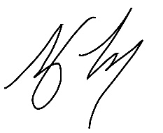

Tony Torcasio
President – Wyndham Vale Cricket Club

