Player Incentive Scheme – Season 2022/23
WVCC has upgraded our incentive program for season 2022 / 2023.

To be eligible to receive season incentives, each player must:
  - Attend 75% of training sessions
  - Attend 75% of Club functions
  - Assist in 2 junior training sessions per season (Junior Coordinator to organise)
  - Must be a fully paid member by the 30th November

The practice of free alcohol as a reward is no longer supported by the committee, and is against RSA principles

    - In 1st grade;
      - Any player scoring 300 runs for the season will receive $300 + $1 per additional run
      - Any player taking 30 wickets for the season will receive $300 + $10 per additional wicket.
      - Any player scoring 100 runs or taking 7 wickets in an innings will receive $100
    - In 2nd grade;
      - Any player scoring 400 runs for the season will receive $200 + $1 per additional run.
      - Any player taking 30 wickets for the season will receive $200 + $5 per additional wicket.
      - Any player scoring 100 runs or taking 7 wickets in an innings will receive $75.
    - In 3rd grade or 4th grade;
      - Any player scoring 100 runs or taking 7 wickets in an innings will receive $50

Conditions:
- Individual match incentives (e.g. 7wi, 100 runs) will be paid on the Saturday of current match is progress or next selection night at the WVCC club rooms.
- Season incentives will be paid at the end of the season.
- Any player may elect to have the incentive reward subtracted from next season's fees. Incentive payments for current season cannot be used to pay current season membership fees.
- Any player who makes themselves unavailable to play at a higher grade level will be ineligible for the incentive scheme.
- Any player who competes in both 1st and 2nd grades over the season and amasses a total of 400 runs or 30 wickets will earn a weighted reward to be determined by the committee.

This policy has been ratified by the committee of Wyndham Vale Cricket Club dated 29th June 2022.

Signed for and on behalf of committee,
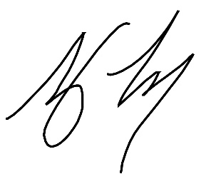

Tony Torcasio
President – Wyndham Vale Cricket Club

