Best and Fairest Policy
1. Definition: Best and Fairest is the term commonly used in Australian sport to describe the player adjudged to have had the best performance in a game or over a season for a given sporting club or competition while not receiving a suspension for misconduct or breaching the rules during that season.
2. This document outlines the policy associate to deciding grade and club champions awards each year.
3. Policy
On completion of the game the umpire or opposition captain are to be asked to provide the 3-2-1 scores for the game just concluded. These are to be handed to President by grade captain who will be responsible to collate results and maintain secrecy of results until announced at the presentation night.
Scores can be passed via:
- Written form (3-2-1 card)
In the event of a player receiving any association and/or club sanctions throughout the year they will be ineligible to receive the award for the current year.
This policy has been ratified by the committee of Wyndham Vale Cricket Club dated 29th June 2022.

Signed for and on behalf of committee,
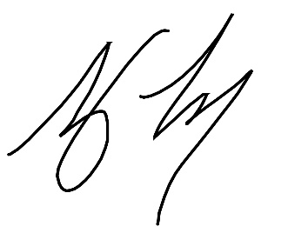
Tony Torcasio
President – Wyndham Vale Cricket Club

